Figure 39. Abandoned pond at the Kulaluk crab farm in 2009.
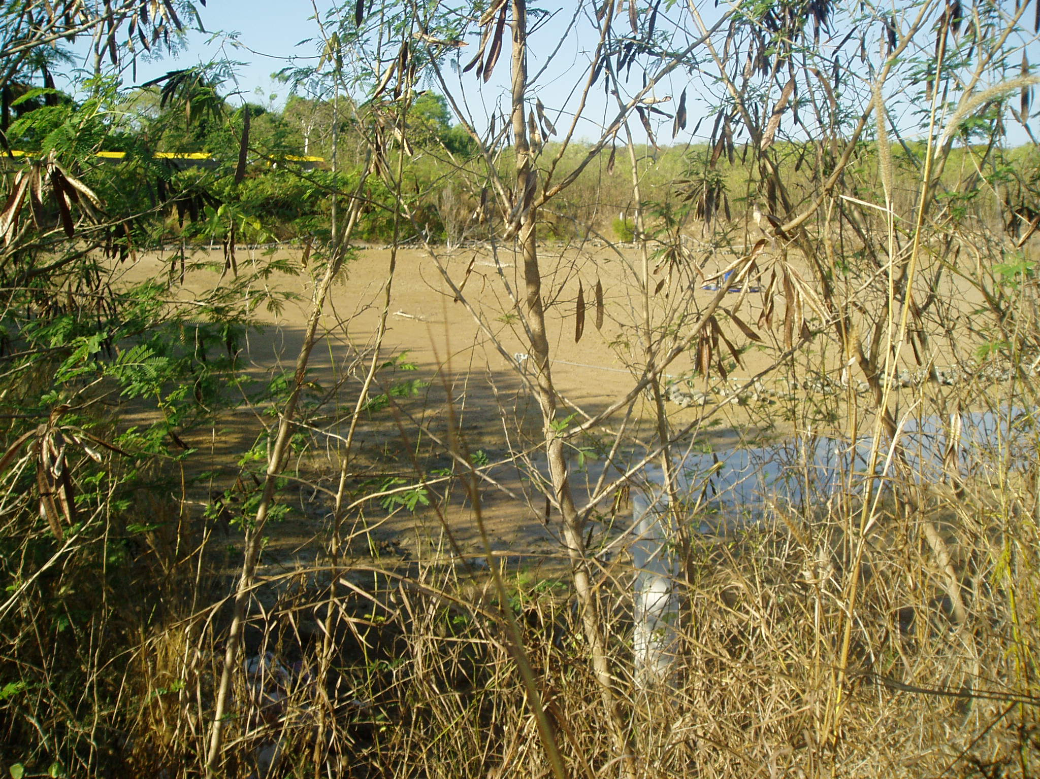

Figure 40. An empty and abandoned pond and infrastructure at Kulaluk, 2009.
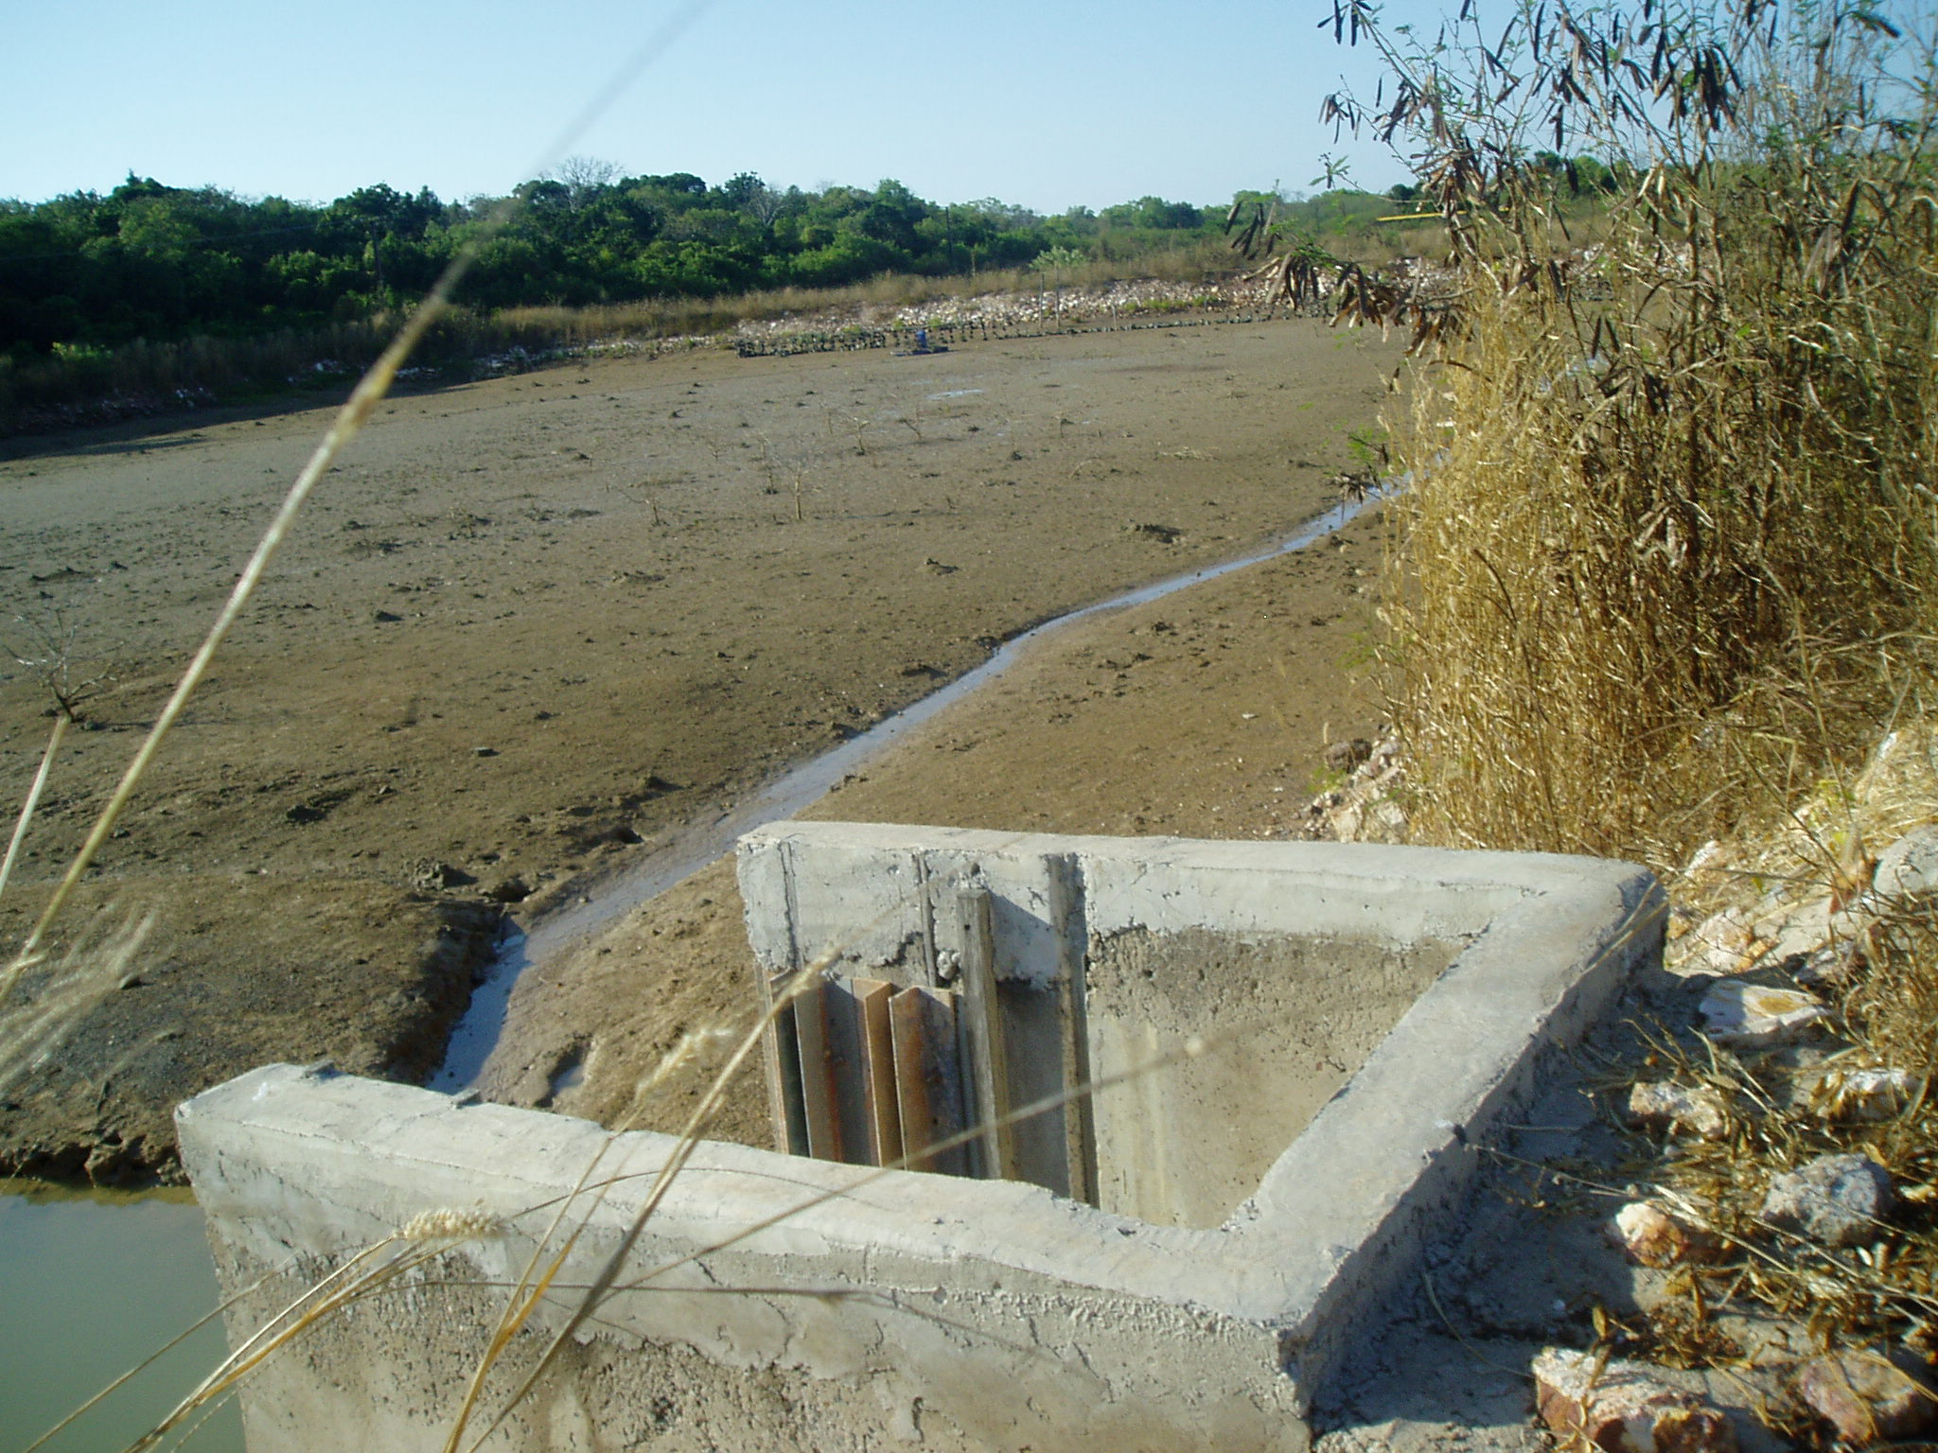

Figure 41. Abandoned generators at the crab farm.
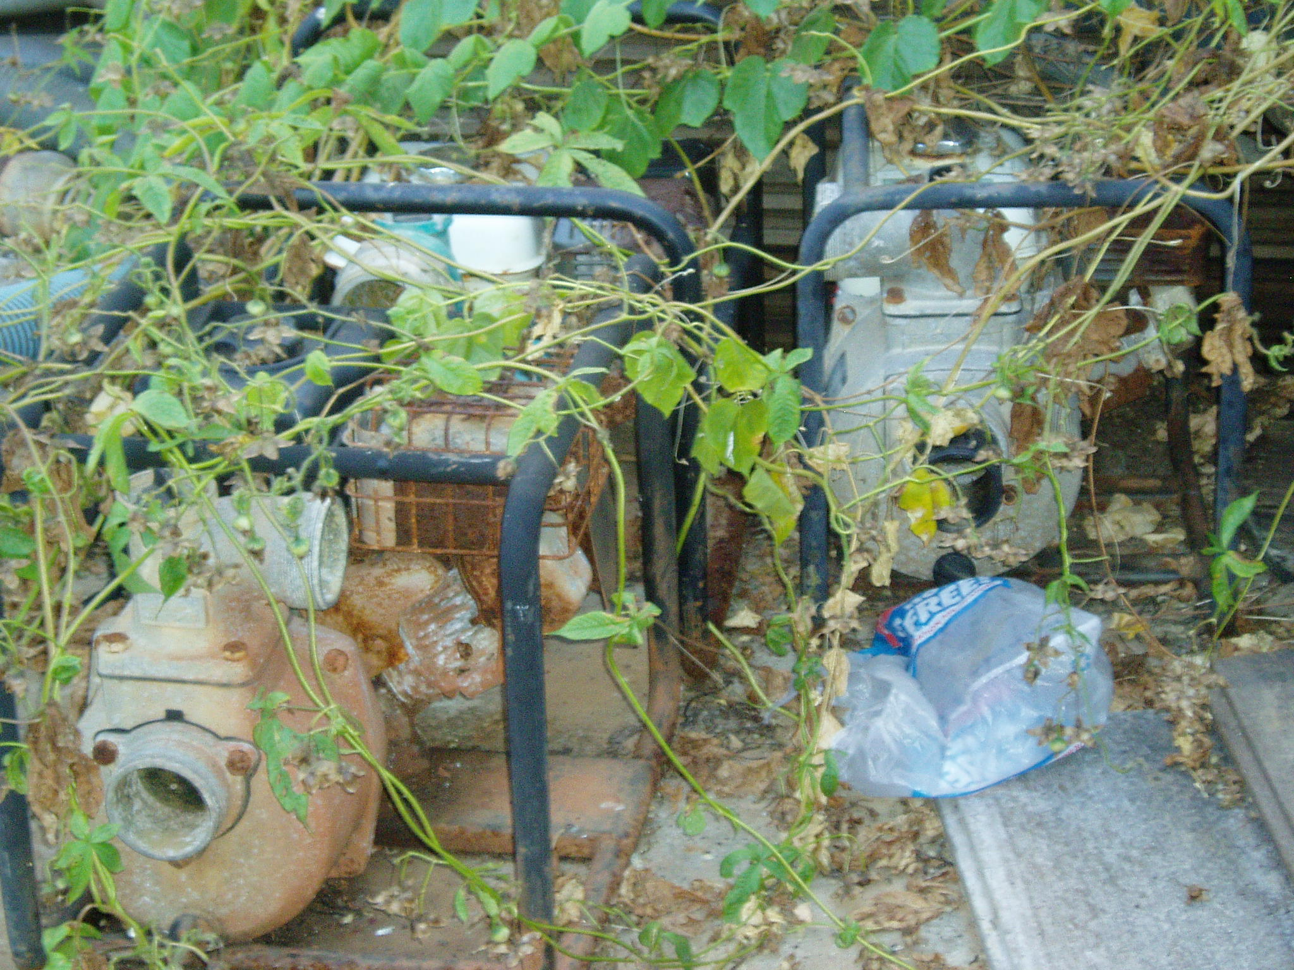

Figure 42. Abandoned pond and gear in 2009
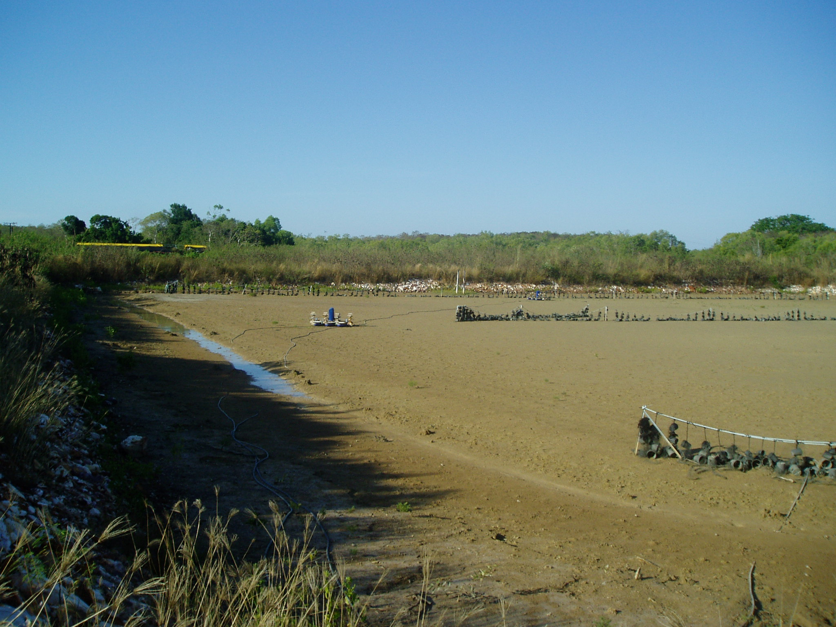

Figure 43. Mangroves growing in abandoned ponds at Kulaluk crab farm in 2009.
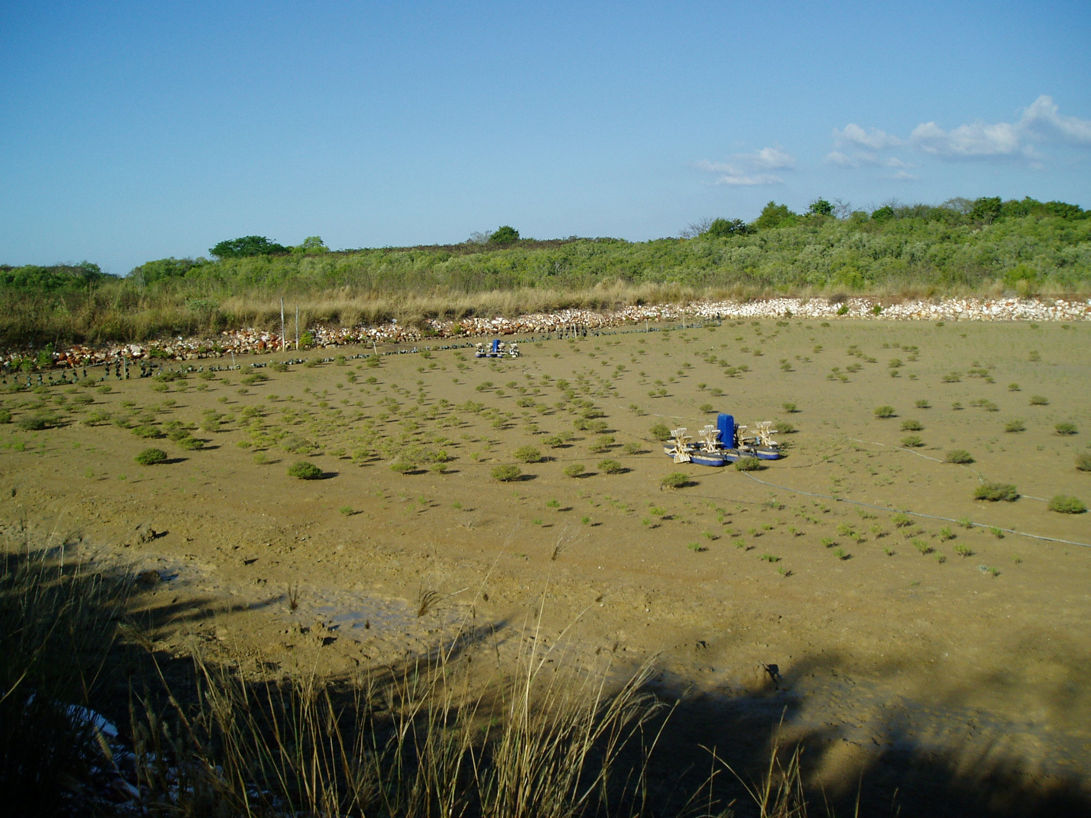

Figure 44. Vines grow on abandoned powerlines leading to Kulaluk crab farm.
